**Chuni Lal Shalla**

[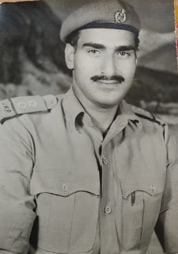](https://1.bp.blogspot.com/-F8iZZe63jLk/X2M0Zi4on2I/AAAAAAAABA0/1_XijyN16AQ2NA54vRiwfUDZ_zvr2rSewCLcBGAsYHQ/s1303/Chuni+Lal+Shalla.jpg)

**About:** Chunni Lal Shalla was born in a Kashmiri Brahmin Zamindar family in a village named "Sheer Jagir" near Sopore in Baramulla.He had his initial education in Sopore and after that he went to Sri Pratap College Srinagar for Higher studies. He always wanted serve his motherland so he joined Jammu and Kashmir Police as a Sub-Inspector.

Police Career.

**Murdered on:**01 May 1990

**Attack details:** Father’s jeep had developed some technical snag so he decided to board the bus to Baramulla. As my father reached the bus stand Kupwara , he sat in the bus while his PSO approached a man wearing a pheran near the butcher’s shop and hugged him telling him “he is in the bus”. PSO checked from the man whether they were carrying the weapon or not. Once the bus moved out of the bus stand a van started following it. After travelling a few kilometres, the van overtook the bus and stopped it. Three men jumped out of the van and one opened the driver’s door and put a gun on his head while other two men entered the bus and shouted my father’s.

**Reason to him target**: C.L Shalla, Police Inspector who got martyred for being an Indian.

**Occupation:** CID Inspector of Jammu & Kashmir Police Chuni Lal Shalla.Chuni Lal Shalla was a kashmiri Hindu.He was posted as CID Inspector of Jammu & Kashmir Police posted at kupwara during the Genocide and Exodus of Kashmiri Hindus.

**Belief:** He always wanted serve his motherland so he joined Jammu and Kashmir Police as a Sub-Inspector.

**URL :** <https://www.newdelhicables.com/2020/09/cid-inspector-of-jammu-kashmir-police.html?m=1>

